Date Last Done
 | J | F | M | A | M | J | J | A | S | O | N | D
Bath
Good brushing
Farrier
Teeth
Vet visit
Wash tack
Wash blanket
Hose down stall
Wash food bucket
Wash water bucket
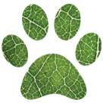
Hygiene Tracker

