Date Last Done
 | J | F | M | A | M | J | J | A | S | O | N | D
Bath
Haircut
Ears
Nails
Teeth
Vet visit
Disinfect bedding
Wash litterbox
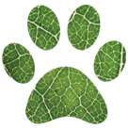
Hygiene Tracker

